1. Install anaconda. Go to [www.anaconda.com](http://www.anaconda.com). Click on download.
2. Double click the downloaded installer and click on Next. Make sure that anaconda is added to the PATH environment.

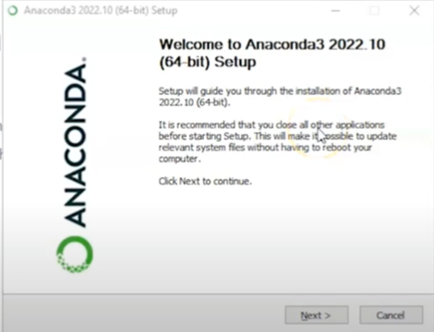 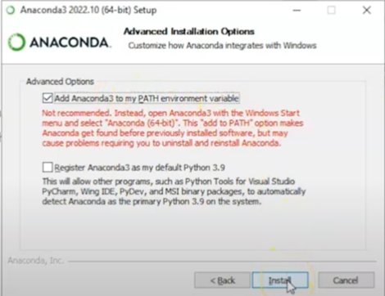

1. Check if anaconda is successfully installed. Go to the windows and search for anaconda prompt. Type in conda –version.

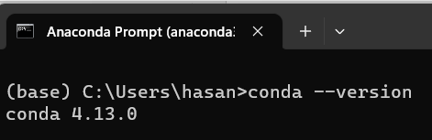

1. To see whether python is correctly installed, open Command Prompt and type python –version and pip –version.

1. Create a virtual environment. In Anaconda Prompt, type in “conda create --name pytorch_env python=3.9”. pytorch_env is our environment name.
2. Activate the virtual environment by typing in “ conda activate pytorch_env”.
3. Install pytorch. Go to pytorch.org.

1. Select the package that meet your system’s requirements. Copy the command and run in Anaconda Prompt. Check the installation by typing “conda list -f pytorch”. If you can see the details of Pytorch installed in your system, that means the installation is successful.
2. Open python in Anaconda Prompt by simply typing “python”. Type in “import torch” and follow with these commands:

torch.cuda.is_available()

torch.cuda.device_count()

torch.cuda.current_device()

torch.cuda.device(0)

torch.cuda.get_device_name(0)

1. Download and install Visual Studio Code (VSCode) from <https://code.visualstudio.com/download>
2. Open VSCode and click CTRL+SHIFT+P -> Python: select interpreter. Choose our the python from our virtual environment as our interpreter.
3. Now we can right a simple python script and save it as a file. Make sure to also choose the command prompt from the view panel on the top right corner. If everything is correct, you should get the same output as shown in the figure below.

